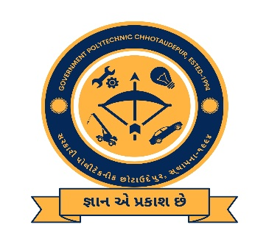

Coordinators: Patron:

Mr. V. J. Pandya (SSIP coordinator, LEE) Mr. R.D.Parmar (I/c Principal, GP Chhotaudepur)

Mr. R.M. Kantharia (Asst SSIP coordinator LEE)

Date: 12/10/2022

Time: 02:00 PM

Venue: Government Polytechnic Chhotaudepur

Organize Awareness program on:

“Sensitization workshop for Potential Investors”

**Government Polytechnic, Chhotaudepur**

**SSIP Cell**

**(Under Directorate of Technical Education, Gujarat)**

**All Branch & All Year Diploma students**